Assignment 13: Image Classification Analysis
3. Tasks:
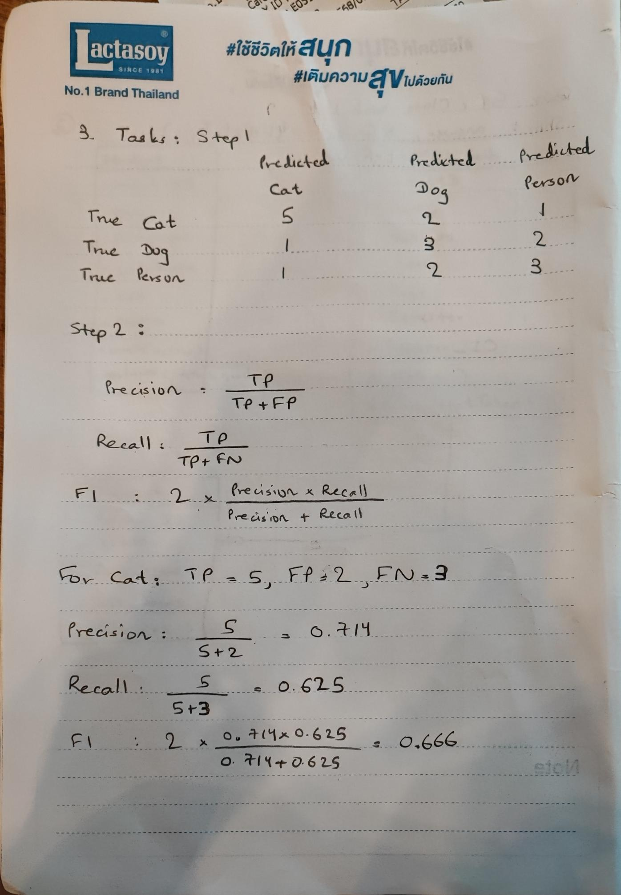
• Step 1: Construct a 3x3 confusion matrix based on the above data. Here's the format for your matrix:
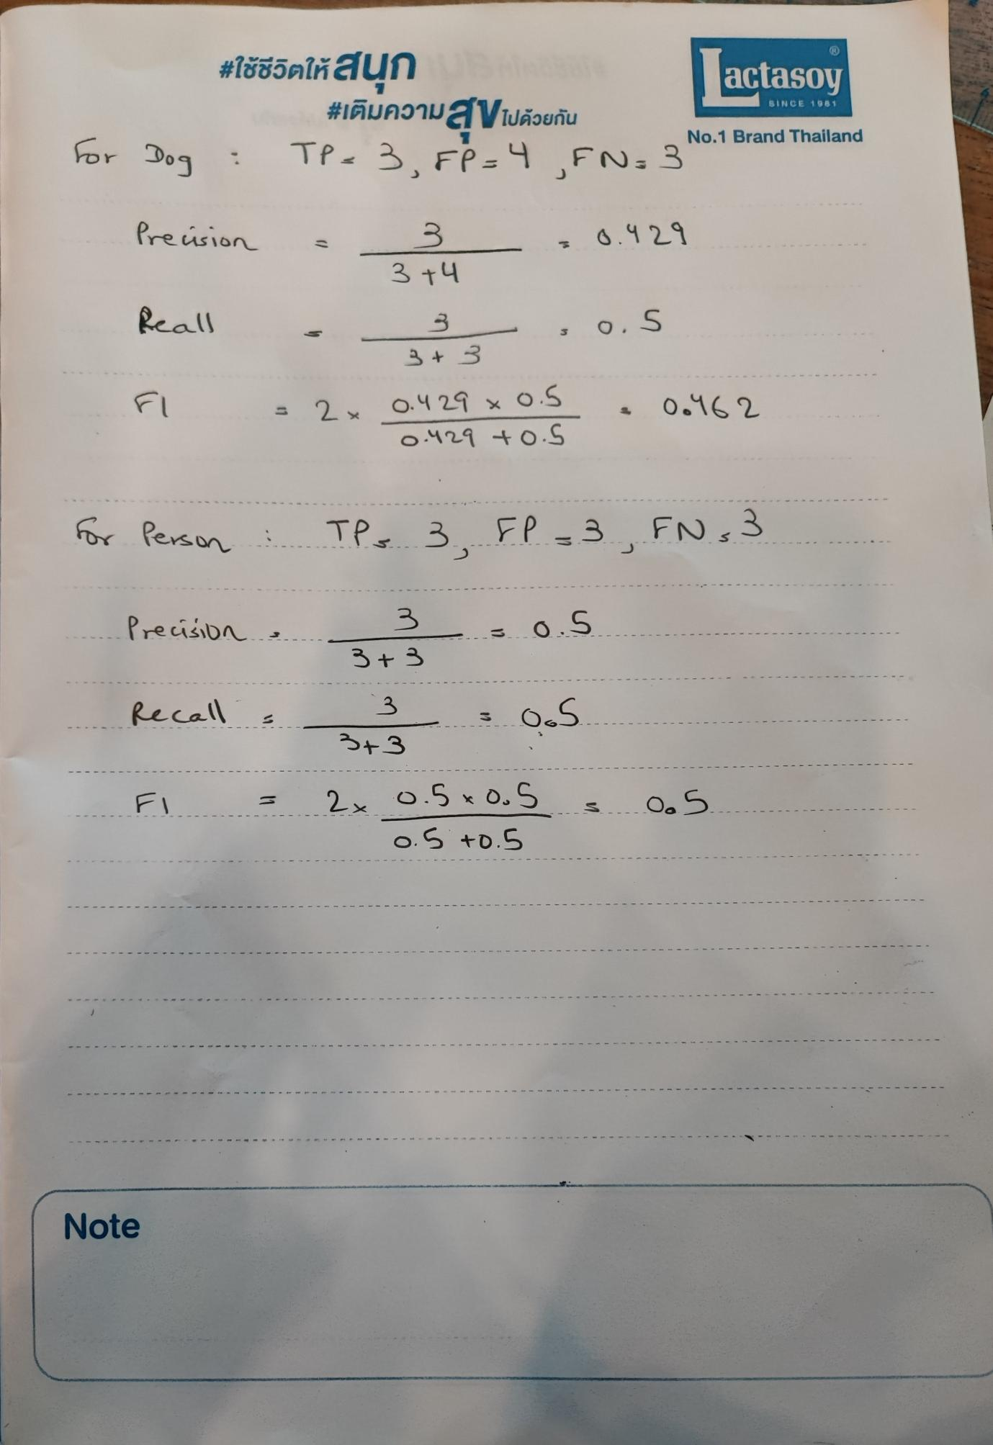
Step 3: Analysis
- Cat: Moderate precision (71.4%) but lower recall (62.5%). The model correctly identifies most Cats but misses some.
- Dog: Poor precision (42.9%) and recall (50%). The model frequently misclassifies Dogs as Cats or Persons.
- Person: Balanced precision and recall (50% each), indicating average performance with room for improvement.

